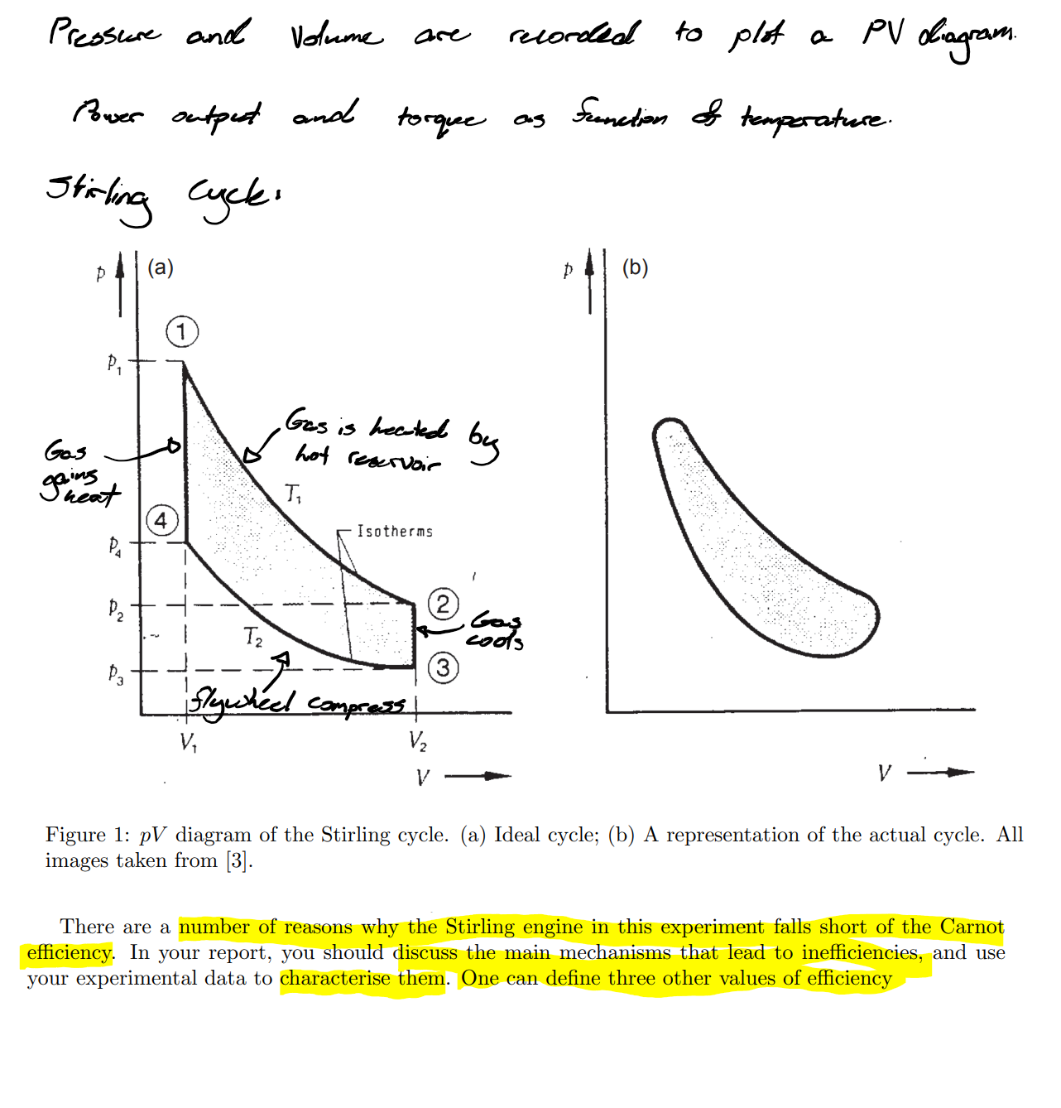

Ink Drawings
Ink Drawings
Ink Drawings
Ink Drawings
Ink Drawings
Ink Drawings
Ink Drawings
Ink Drawings
Ink Drawings
Ink Drawings
Ink Drawings
Ink Drawings
Ink Drawings
Ink Drawings
Ink Drawings
Ink Drawings
Ink Drawings
Ink Drawings
Ink Drawings
Ink Drawings
Ink Drawings
Ink Drawings
Ink Drawings
Ink Drawings
Ink Drawings
Ink Drawings
Ink Drawings
Ink Drawings
Ink Drawings
Ink Drawings
Ink Drawings
Ink Drawings
Ink Drawings
Ink Drawings
Ink Drawings
Ink Drawings
Ink Drawings
Ink Drawings
Ink Drawings
Ink Drawings
Ink Drawings
Ink Drawings
Ink Drawings
Ink Drawings
Ink Drawings
Ink Drawings
Ink Drawings
Ink Drawings
Ink Drawings
Ink Drawings
Ink Drawings
Ink Drawings
Ink Drawings
Ink Drawings
Ink Drawings
Ink Drawings
Ink Drawings
Ink Drawings
Ink Drawings
Ink Drawings
Ink Drawings
Ink Drawings
Ink Drawings
Ink Drawings
Ink Drawings
Ink Drawings
Ink Drawings
Ink Drawings
Ink Drawings
Ink Drawings
Ink Drawings
Ink Drawings
Ink Drawings
Ink Drawings
Ink Drawings
Ink Drawings
Ink Drawings
Ink Drawings
Ink Drawings
Ink Drawings
Ink Drawings
Ink Drawings
Ink Drawings
Ink Drawings
Ink Drawings
Ink Drawings
Ink Drawings
Ink Drawings
Ink Drawings
Ink Drawings
Ink Drawings
Ink Drawings
Ink Drawings
Ink Drawings
Ink Drawings
Ink Drawings
Ink Drawings
Ink Drawings
Ink Drawings
Ink Drawings
Ink Drawings
Ink Drawings
Ink Drawings
Ink Drawings
Ink Drawings
Ink Drawings
Ink Drawings
Ink Drawings
Ink Drawings
Ink Drawings
Ink Drawings
Ink Drawings
Ink Drawings
Ink Drawings
Ink Drawings
Ink Drawings
Ink Drawings
Ink Drawings
Ink Drawings
Ink Drawings
Ink Drawings
Ink Drawings
Ink Drawings
Ink Drawings
Ink Drawings
Ink Drawings
Ink Drawings
Ink Drawings
Ink Drawings
Ink Drawings
Ink Drawings
Ink Drawings
Ink Drawings
Ink Drawings
Ink Drawings
Ink Drawings
Ink Drawings
Ink Drawings
Ink Drawings
Ink Drawings
Ink Drawings
Ink Drawings
Ink Drawings
Ink Drawings
Ink Drawings
Ink Drawings
Ink Drawings
Ink Drawings
Ink Drawings
Ink Drawings
Ink Drawings
Ink Drawings
Ink Drawings
Ink Drawings
Ink Drawings
Ink Drawings
Ink Drawings
Ink Drawings
Ink Drawings
Ink Drawings
Ink Drawings
Ink Drawings
Ink Drawings
Ink Drawings
Ink Drawings
Ink Drawings
Ink Drawings
Ink Drawings
Ink Drawings
Ink Drawings
Ink Drawings
Ink Drawings
Ink Drawings
Ink Drawings
Ink Drawings
Ink Drawings
Ink Drawings
Ink Drawings
Ink Drawings
Ink Drawings
Ink Drawings
Ink Drawings
Ink Drawings
Ink Drawings
Ink Drawings
Ink Drawings
Ink Drawings
Ink Drawings
Ink Drawings
Ink Drawings
Ink Drawings
Ink Drawings
Ink Drawings
Ink Drawings
Ink Drawings
Ink Drawings
Ink Drawings


Ink Drawings
Ink Drawings
Ink Drawings
Ink Drawings
Ink Drawings
Ink Drawings
Ink Drawings
Ink Drawings
Ink Drawings
Ink Drawings
Ink Drawings
Ink Drawings
Ink Drawings
Ink Drawings
Ink Drawings
Ink Drawings
Ink Drawings
Ink Drawings
Ink Drawings
Ink Drawings
Ink Drawings
Ink Drawings
Ink Drawings
Ink Drawings
Ink Drawings
Ink Drawings
Ink Drawings
Ink Drawings
Ink Drawings
Ink Drawings
Ink Drawings
Ink Drawings
Ink Drawings
Ink Drawings
Ink Drawings
Ink Drawings
Ink Drawings
Ink Drawings
Ink Drawings
Ink Drawings
Ink Drawings
Ink Drawings
Ink Drawings
Ink Drawings
Ink Drawings
Ink Drawings
Ink Drawings
Ink Drawings
Ink Drawings
Ink Drawings
Ink Drawings
Ink Drawings
Ink Drawings
Ink Drawings
Ink Drawings
Ink Drawings
Ink Drawings
Ink Drawings
Ink Drawings
Ink Drawings
Ink Drawings
Ink Drawings
Ink Drawings
Ink Drawings
Ink Drawings
Ink Drawings
Ink Drawings
Ink Drawings
Ink Drawings
Ink Drawings
Ink Drawings
Ink Drawings
Ink Drawings
Ink Drawings
Ink Drawings
Ink Drawings
Ink Drawings
Ink Drawings
Ink Drawings
Ink Drawings
Ink Drawings
Ink Drawings
Ink Drawings
Ink Drawings
Ink Drawings
Ink Drawings
Ink Drawings
Ink Drawings
Ink Drawings
Ink Drawings
Ink Drawings
Ink Drawings
Ink Drawings
Ink Drawings
Ink Drawings
Ink Drawings
Ink Drawings
Ink Drawings
Ink Drawings
Ink Drawings
Ink Drawings
Ink Drawings
Ink Drawings
Ink Drawings
Ink Drawings
Ink Drawings
Ink Drawings
Ink Drawings
Ink Drawings
Ink Drawings
Ink Drawings
Ink Drawings
Ink Drawings
Ink Drawings
Ink Drawings
Ink Drawings
Ink Drawings
Ink Drawings
Ink Drawings
Ink Drawings
Ink Drawings
Ink Drawings
Ink Drawings
Ink Drawings
Ink Drawings
Ink Drawings
Ink Drawings
Ink Drawings
Ink Drawings
Ink Drawings
Ink Drawings
Ink Drawings
Ink Drawings
Ink Drawings
Ink Drawings
Ink Drawings
Ink Drawings
Ink Drawings
Ink Drawings
Ink Drawings
Ink Drawings
Ink Drawings
Ink Drawings
Ink Drawings
Ink Drawings
Ink Drawings
Ink Drawings
Ink Drawings
Ink Drawings
Ink Drawings
Ink Drawings
Ink Drawings
Ink Drawings
Ink Drawings
Ink Drawings
Ink Drawings
Ink Drawings
Ink Drawings
Ink Drawings
Ink Drawings
Ink Drawings
Ink Drawings
Ink Drawings
Ink Drawings
Ink Drawings
Ink Drawings
Ink Drawings
Ink Drawings
Ink Drawings
Ink Drawings
Ink Drawings
Ink Drawings
Ink Drawings
Ink Drawings
Ink Drawings
Ink Drawings
Ink Drawings
Ink Drawings
Ink Drawings
Ink Drawings
Ink Drawings
Ink Drawings
Ink Drawings
Ink Drawings
Ink Drawings
Ink Drawings
Ink Drawings
Ink Drawings
Ink Drawings
Ink Drawings
Ink Drawings
Ink Drawings
Ink Drawings
Ink Drawings
Ink Drawings
Ink Drawings
Ink Drawings
Ink Drawings
Ink Drawings
Ink Drawings
Ink Drawings
Ink Drawings
Ink Drawings
Ink Drawings
Ink Drawings
Ink Drawings
Ink Drawings
Ink Drawings
Ink Drawings
Ink Drawings
Ink Drawings
Ink Drawings
Ink Drawings
Ink Drawings
Ink Drawings
Ink Drawings
Ink Drawings
Ink Drawings
Ink Drawings


(Note CASSY software gave extremely bad values, so we decided I would make a Matlab script)

Ink Drawings
Ink Drawings
Ink Drawings
Ink Drawings
Ink Drawings
Ink Drawings
Ink Drawings
Ink Drawings
Ink Drawings
Ink Drawings
Ink Drawings
Ink Drawings
Ink Drawings
Ink Drawings
Ink Drawings
Ink Drawings
Ink Drawings
Ink Drawings
Ink Drawings
Ink Drawings
Ink Drawings
Ink Drawings
Ink Drawings
Ink Drawings
Ink Drawings
Ink Drawings
Ink Drawings
Ink Drawings
Ink Drawings
Ink Drawings
Ink Drawings
Ink Drawings
Ink Drawings
Ink Drawings
Ink Drawings
Ink Drawings
Ink Drawings
Ink Drawings
Ink Drawings
Ink Drawings
Ink Drawings
Ink Drawings
Ink Drawings
Ink Drawings
Ink Drawings
Ink Drawings
Ink Drawings
Ink Drawings
Ink Drawings
Ink Drawings
Ink Drawings
Ink Drawings
Ink Drawings
Ink Drawings
Ink Drawings
Ink Drawings
Ink Drawings
Ink Drawings
Ink Drawings
Ink Drawings
Ink Drawings
Ink Drawings
Ink Drawings
Ink Drawings
Ink Drawings
Ink Drawings
Ink Drawings
Ink Drawings
Ink Drawings
Ink Drawings
Ink Drawings
Ink Drawings
Ink Drawings
Ink Drawings
Ink Drawings
Ink Drawings
Ink Drawings
Ink Drawings
Ink Drawings
Ink Drawings
Ink Drawings
Ink Drawings
Ink Drawings
Ink Drawings
Ink Drawings
Ink Drawings
Ink Drawings
Ink Drawings
Ink Drawings
Ink Drawings
Ink Drawings
Ink Drawings
Ink Drawings


Ink Drawings
Ink Drawings
Ink Drawings
Ink Drawings
Ink Drawings
Ink Drawings
Ink Drawings
Ink Drawings
Ink Drawings
Ink Drawings
Ink Drawings
Ink Drawings
Ink Drawings
Ink Drawings
Ink Drawings
Ink Drawings
Ink Drawings
Ink Drawings
Ink Drawings
Ink Drawings
Ink Drawings
Ink Drawings
Ink Drawings
Ink Drawings
Ink Drawings
Ink Drawings
Ink Drawings
Ink Drawings
Ink Drawings
Ink Drawings
Ink Drawings
Ink Drawings
Ink Drawings
Ink Drawings
Ink Drawings
Ink Drawings
Ink Drawings
Ink Drawings
Ink Drawings
Ink Drawings
Ink Drawings
Ink Drawings
Ink Drawings
Ink Drawings
Ink Drawings
Ink Drawings
Ink Drawings
Ink Drawings
Ink Drawings
Ink Drawings
Ink Drawings
Ink Drawings
Ink Drawings
Ink Drawings
Ink Drawings
Ink Drawings
Ink Drawings
Ink Drawings
Ink Drawings
Ink Drawings
Ink Drawings
Ink Drawings
Ink Drawings
Ink Drawings
Ink Drawings
Ink Drawings
Ink Drawings
Ink Drawings
Ink Drawings
Ink Drawings
Ink Drawings
Ink Drawings
Ink Drawings
Ink Drawings
Ink Drawings
Ink Drawings
Ink Drawings
Ink Drawings
Ink Drawings
Ink Drawings
Ink Drawings
Ink Drawings
Ink Drawings
Ink Drawings
Ink Drawings
Ink Drawings
Ink Drawings
Ink Drawings
Ink Drawings
Ink Drawings
Ink Drawings
Ink Drawings
Ink Drawings
Ink Drawings
Ink Drawings
Ink Drawings
Ink Drawings
Ink Drawings
Ink Drawings
Ink Drawings
Ink Drawings
Ink Drawings
Ink Drawings
Ink Drawings
Ink Drawings
Ink Drawings
Ink Drawings
Ink Drawings
Ink Drawings
Ink Drawings
Ink Drawings
Ink Drawings
Ink Drawings
Ink Drawings
Ink Drawings
Ink Drawings
Ink Drawings
Ink Drawings
Ink Drawings
Ink Drawings
Ink Drawings
Ink Drawings
Ink Drawings
Ink Drawings
Ink Drawings
Ink Drawings
Ink Drawings
Ink Drawings
Ink Drawings
Ink Drawings
Ink Drawings
Ink Drawings
Ink Drawings
Ink Drawings
Ink Drawings
Ink Drawings
Ink Drawings
Ink Drawings
Ink Drawings
Ink Drawings
Ink Drawings
Ink Drawings
Ink Drawings
Ink Drawings
Ink Drawings
Ink Drawings
Ink Drawings
Ink Drawings
Ink Drawings
Ink Drawings
Ink Drawings
Ink Drawings
Ink Drawings
Ink Drawings
Ink Drawings
Ink Drawings
Ink Drawings
Ink Drawings
Ink Drawings
Ink Drawings
Ink Drawings
Ink Drawings
Ink Drawings


Ink Drawings
Ink Drawings
Ink Drawings
Ink Drawings
Ink Drawings
Ink Drawings
Ink Drawings
Ink Drawings
Ink Drawings
Ink Drawings
Ink Drawings
Ink Drawings
Ink Drawings
Ink Drawings
Ink Drawings
Ink Drawings
Ink Drawings
Ink Drawings
Ink Drawings
Ink Drawings
Ink Drawings
Ink Drawings
Ink Drawings
Ink Drawings
Ink Drawings
Ink Drawings
Ink Drawings
Ink Drawings
Ink Drawings
Ink Drawings
Ink Drawings
Ink Drawings
Ink Drawings
Ink Drawings
Ink Drawings
Ink Drawings
Ink Drawings
Ink Drawings
Ink Drawings
Ink Drawings
Ink Drawings
Ink Drawings
